

**OPERATING SYSTEM PROJECT REPORT**

**UNIX SHELL (Combining Commands)**

**Group Members :**

1. **Danish 21k-4829**

**Github link. https://github.com/DanishQadir/OS_Project**

1. **INTRODUCTION :**

The project name is “UNIX SHELL”. It’s all about creating new terminals in linux, there are also other shells like bash, zsh etcIn this we add different system commands to perform different tasks in the linux terminal. Combined with the power and flexibility the command line offers , means that using it may be essential when we are performing different tasks.this report provides an overview of the project , detailing its motivation , problem statement ,contributions , methodology ,results and concluding remarks.

1. **FEATURES:**
   * Interactive user interface
   * Animated view
   * Save Your Time
   * Perfect for Programmers
   * Command History
   * Fast & Efficient

**3.MOTIVATION:**

The motivation behind this project stems from the limitations observed in existing Unix shells. The team aspires to address these shortcomings by creating a shell that offers a more sophisticated user interface, fast execution, and the ability to seamlessly combine commands. The motivation is to enhance the user experience and productivity in command-line environments.

**4. Problem Statement**

Existing Unix shells may lack advanced features, a user-friendly interface, and efficient command combination capabilities. The project addresses these issues by designing a shell that caters to the needs of users requiring a more robust and feature-rich command-line experience. The goal is to overcome the limitations of conventional shells and provide a versatile alternative.

**5. Contribution**

The project's primary contributions include:

* Complex Linux Shell: Development of a feature-rich shell capable of handling complex commands and operations.
* User-Friendly Interface: Designing an intuitive and visually appealing user interface to enhance user experience.
* Efficiency: Optimizing the shell for fast execution and efficient use of system resources.
* Command Combination: Introducing the capability to combine different commands within the shell for enhanced functionality.

**6. Methodology**

The project utilizes a combination of Shell scripting and C/C++ libraries for system calls. The development process involves designing a user-friendly interface, implementing features, and optimizing the shell for efficiency. The methodology focuses on compatibility with Linux/Ubuntu systems and ensuring seamless access to the operating system. Noteworthy aspects include input/output redirection, command parsing, and handling of pipes for command communication.

**7. Results and Discussion**

The Unix Shell project has successfully delivered on its objectives. The results showcase a powerful shell with a feature-rich command-line interface. The discussion covers key features, challenges faced during development, and potential areas for future improvement. Notably, the implementation of input/output redirection, command parsing, and pipe handling are discussed in detail.

**8.Code Screenshot** 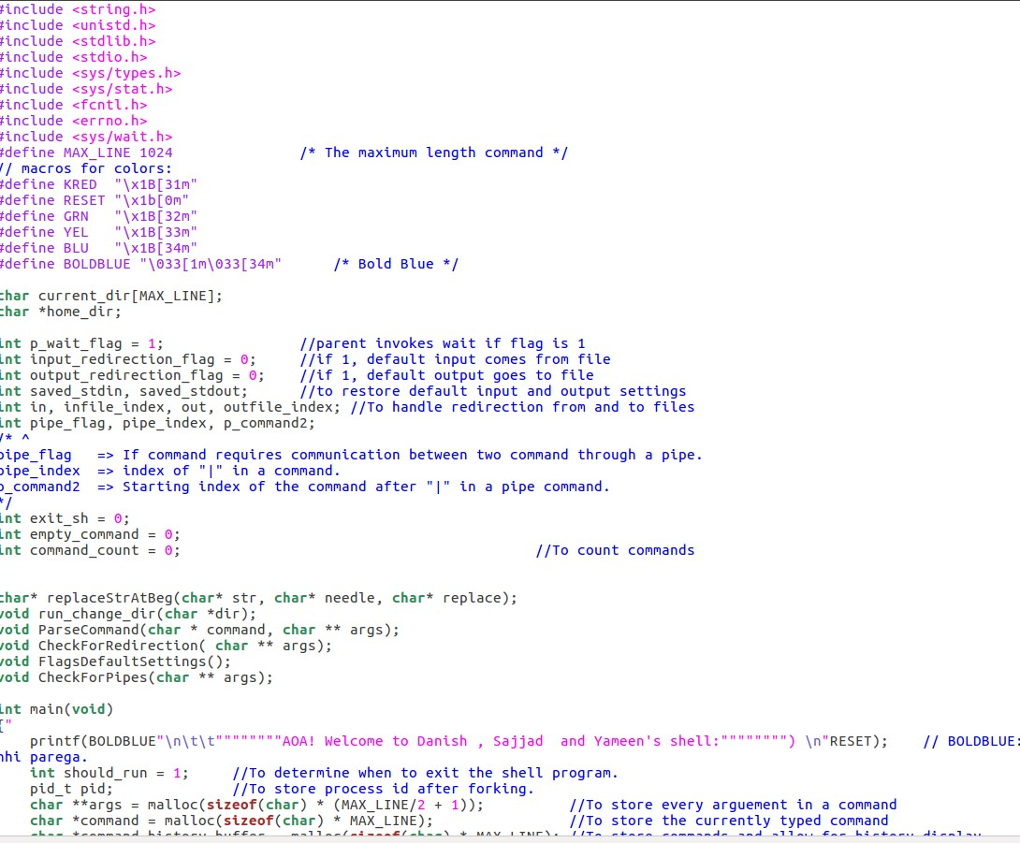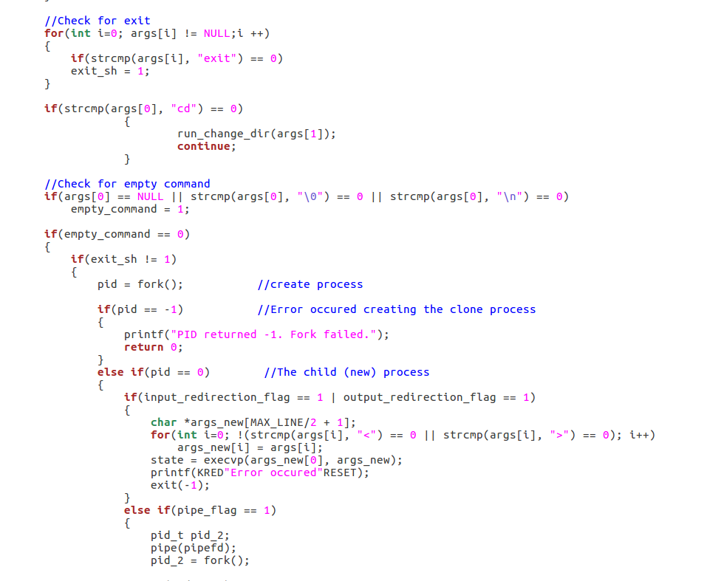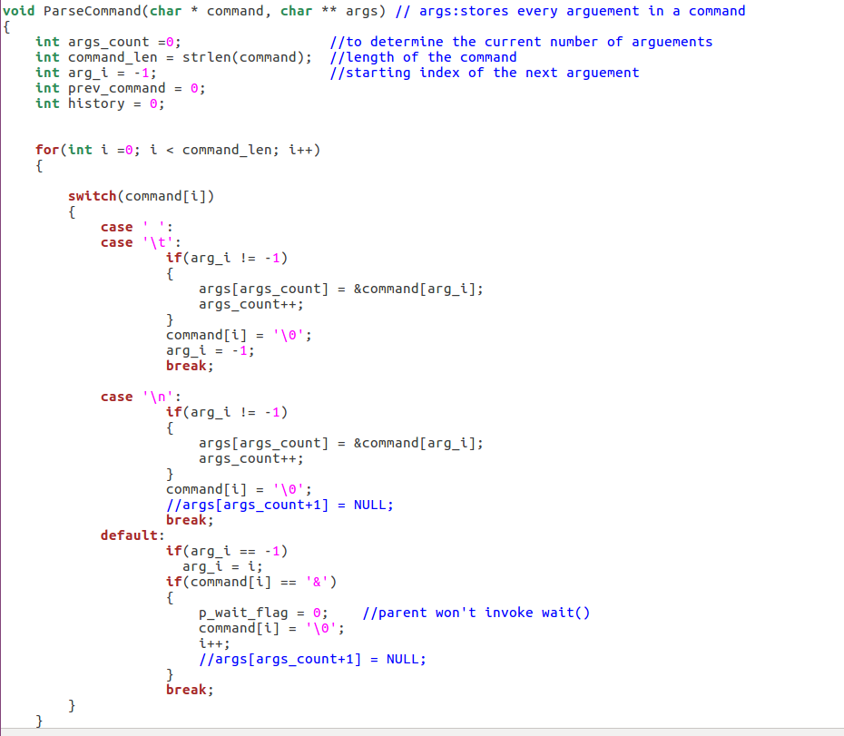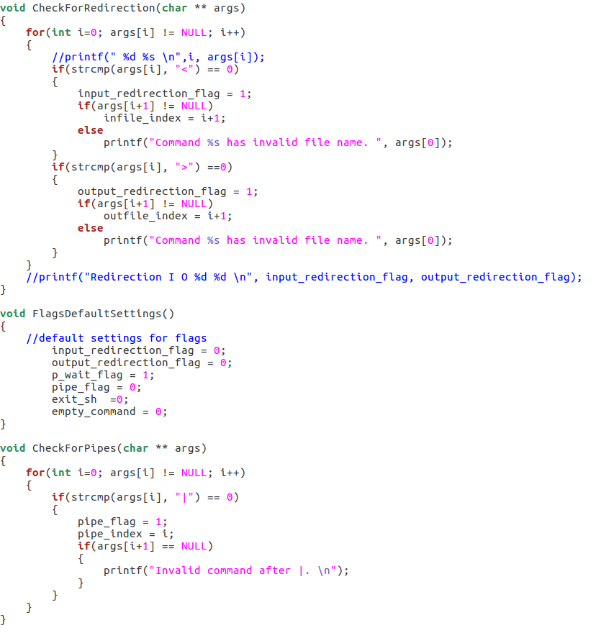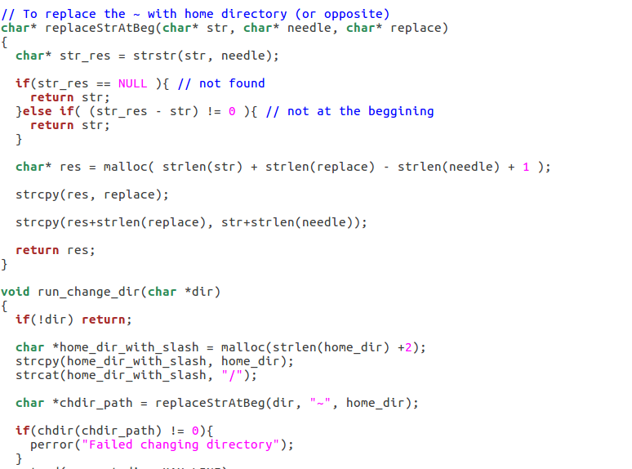

**9.output**

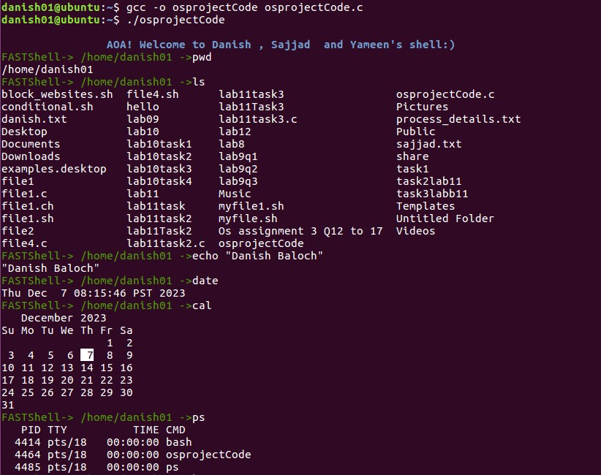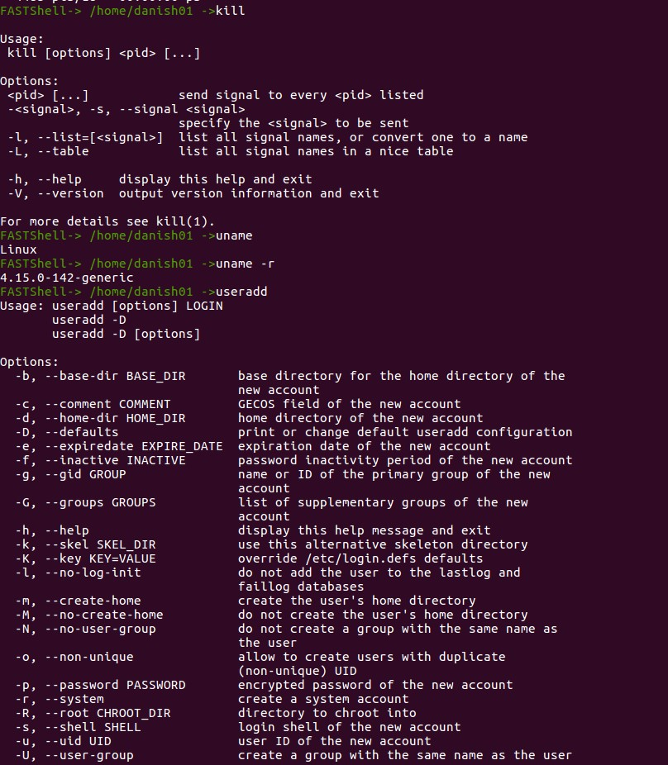

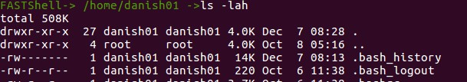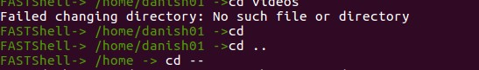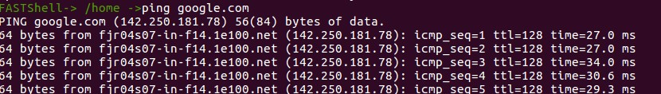

**THE END**